

R3

**(Reduce Reuse Recycle)**

**2017-18**

**Project Information: Client Information:**

**Grade:** Middle School **MS. Gemma Evans**

**School:** Patapsco Recycle Coordinator

**State Representing:** Maryland Howard County Dept. of Public Works

**Project Outline:**Efficient recyclable identificationColumbia, MD

**Project Technology:** Arduino **Mr. James Irvin( Jim Irvin)**

**MESA Coordinator**: Ms. Danielle Stephenson Director

**Grade**: Middle school

**Team Name :**The RoboKnights

Howard County Dept. of Public Works

Ellicott City, MD

**Team Members**:

Harini Devireddy

Pragna Yalamanchili

Srinidhi Akella

Venya Karri

**Problem Statement:**

Lot of recyclable items are being thrown into the trash and being sent to landfills everyday, this creates toxic chemicals that heat up the earth and contributes to global warming. Another issue with recyclable items in Landfills is it has life span of 500 to 1000 yrs to completely biodegrade. As per 2013 EPA (Environmental protection Agency) study, an average american wastes about 4 pounds of materials per person every day. Another analysis forecasts over 50% of landfill can potentially to be recycled. Based on our research there is no distinct product that can identify all types of recyclable items with appropriate prompts to avoid intermix of trash and recyclable items.

Bottomline is inability to efficiently segregate recyclable items from trash causes

environmental pollution and opportunity lost in saving energy.

**Approach:** To address client needs , we followed standard engineering design process steps **ASK** → **IMAGINE** → **PLAN** → **CREATE** → **IMPROVE** → SHARE solution

**1. ASK:**

**Client Requirements:**

* + Need a device to identify recyclable items, and restrict Recyclable items to be intermixed with the trash
  + Needs to be weatherproof and avoid damage from trash inside the container
  + Needs to have display panel for friendly usability and buzzer prompting
  + Efficient Proximity sensing of recyclable items
  + Scope is limited for home usage - Needs further improvements for commercial usage
  + Recyclables should be fed individually to container
  + Recyclables should be clean, dry and empty

**Background Research:** We leveraged our prior knowledge on land pollution and extended the research in identifying source of the current problem statement, variability scenarios, impact analysis and problem resolution approaches. We performed some cases studies e.g. the regular way the community fills trash along with recyclable items and how it ends up in landfills, recycle 1 soda tin run a TV for 2 hours approximately.

We extended our research on saving energy and natural resources, which helps to reduce carbon emissions and minimizes contribution to global warming by appropriate recycling. Please refer to appendix for research links.

* Recycling 1 ton of plastic can save an equivalent of 2 people’s energy used for 1 year
* Manufacturing products from recycled paper and plastic reduces Water Pollution by 35% and Air Pollution by 73%
* One Plastic bottle can save enough energy to power a 60 watt light bulb for 6 hours
* It takes about 25 recycled bottles to make one fleece jacket.

**Constraints of existing devices:** We performed research on existing tools capabilities and deficiencies. The results show that there is no one distinct product that can identify all types of recyclable items. None of the devices in the market, surprisingly don't have display, prompting and notification capabilities.

**2. IMAGINE:**

**Brainstorming/ Choose Solution:** We came up the 3 different solution approaches in addressing the problem.

1. A device to identify recyclable items from the **settled items** of the trash bin.

2. A device to identify recyclable items while throwing into **(free flow)** the trash bin without lid.

3. A device to identify recyclable items while **throwing into** the trash bin with lid.

But after our brainstorm discussions, we found it is practically difficult to identify settled recyclable items from trash bin and also for free flow items without lid. So finally we chose a option 3 as viable solution.

**3. PLAN:**

**Flow Diagram of the Device:** 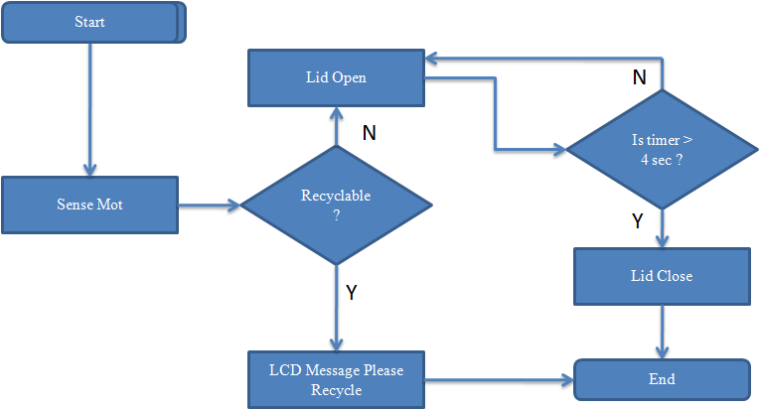

**Modules Breakdown:** Design and development work is split into 3 modules:

1. Metal Detector (Inductive Proximity Sensor)
2. Motion Detector (Ultrasonic Sensor)
3. Display Panel (LCD)

**Coding and Engineering Standards:** We took references from nextgeneration.org for the engineering standards and followed below.

3-5-ETS1-2 3-5-ETS1-3

Additionally we followed coding standards for arduino device programs like naming convention for files/variables/functions, single line comments, block comments etc.

**Review Design:** Each individual contributor presented their module design in multiple iterations to the peers to identify/resolve modular design dependencies, and ensure it can work collaboratively in order to meet client requirements. Post peer review/s had periodical reviews with school MESA coordinator.

**Responsibilities of Team Members:**

|  |  |  |  |
| --- | --- | --- | --- |
| **Venya** | **Srinidhi** | **Pragna** | **Harini** |
| → Design, coding and testing of **Module 1**  → Prototype Assembly  → Technical Presentation | → Design, coding and testing of **Module 2**  → Prototype Assembly  → Project Report | → Design, coding and testing of **Module 3**  → Prototype Assembly  → Prototype Pitch | → Design, coding and testing of **Module 3**  → Prototype Assembly  → Poster |

**Materials Finalized:**

* 1 Arduino Mega ATmega2560
* 1 Inductive Proximity Sensor( NPN type)
* 1 Ultrasonic Sensor (HC-SR04)
* 1 Liquid Crystal Display (HC1624 LCD)
* 1 Device holding box
* 1 Buzzer
* 1 Trash bin for prototype
* 6V battery ( Quantity 4)
* 1 DC Servo (LS-0009AF digital)
* 1 Battery holder
* 1 MOSFET( NTE 960)

**Technology:** Arduino Programming Language

**4. CREATE:**

**Implementation Steps:** All the teams members has been assigned with specific module tasks to perform development in parallel mode with multiple iterations. Post Unit development effort all modules has been integrated to work in union.

**1. Metal Detector (Inductive Proximity):** Metal Detector is the inductive proximity sensor and been used in our project in the context of detecting the metal items mistakenly getting thrown into the trash. Metal detector module upon identification of metal sends signals in a serial fashion to the code deployed on the arduino nano board and then communicates with LCD module to display the relevant prompts for user to recycle if it is a metal. The detector detects most of the metals and the maximum distance for the item to get detected is 8mm**.**

**2. Motion Detector (Ultrasonic):** Motion Detector (Model# HC-SR04) detects the motion of objects within a range of 2 cm to 400 cm and sends serial signals to the arduino board then which is programmed to open /close the lid. This module is integrated with the metal detector module to identify type of material and execute lid open/close action. DC Servo motor is used to help lifting the trash bin lid.

3.**Display Panel (LCD) and Buzzer:** Based on signals received from metal detector module Liquid Crystal Display (LCD) panel displays relevant prompts. e.g. If it is metal or plastic it displays “Please Recycle”. These prompts helps the user to act accordingly to recycle it and avoid any environmental pollution.Buzzer is an additional component for sound prompt.

**Prototype Model:**

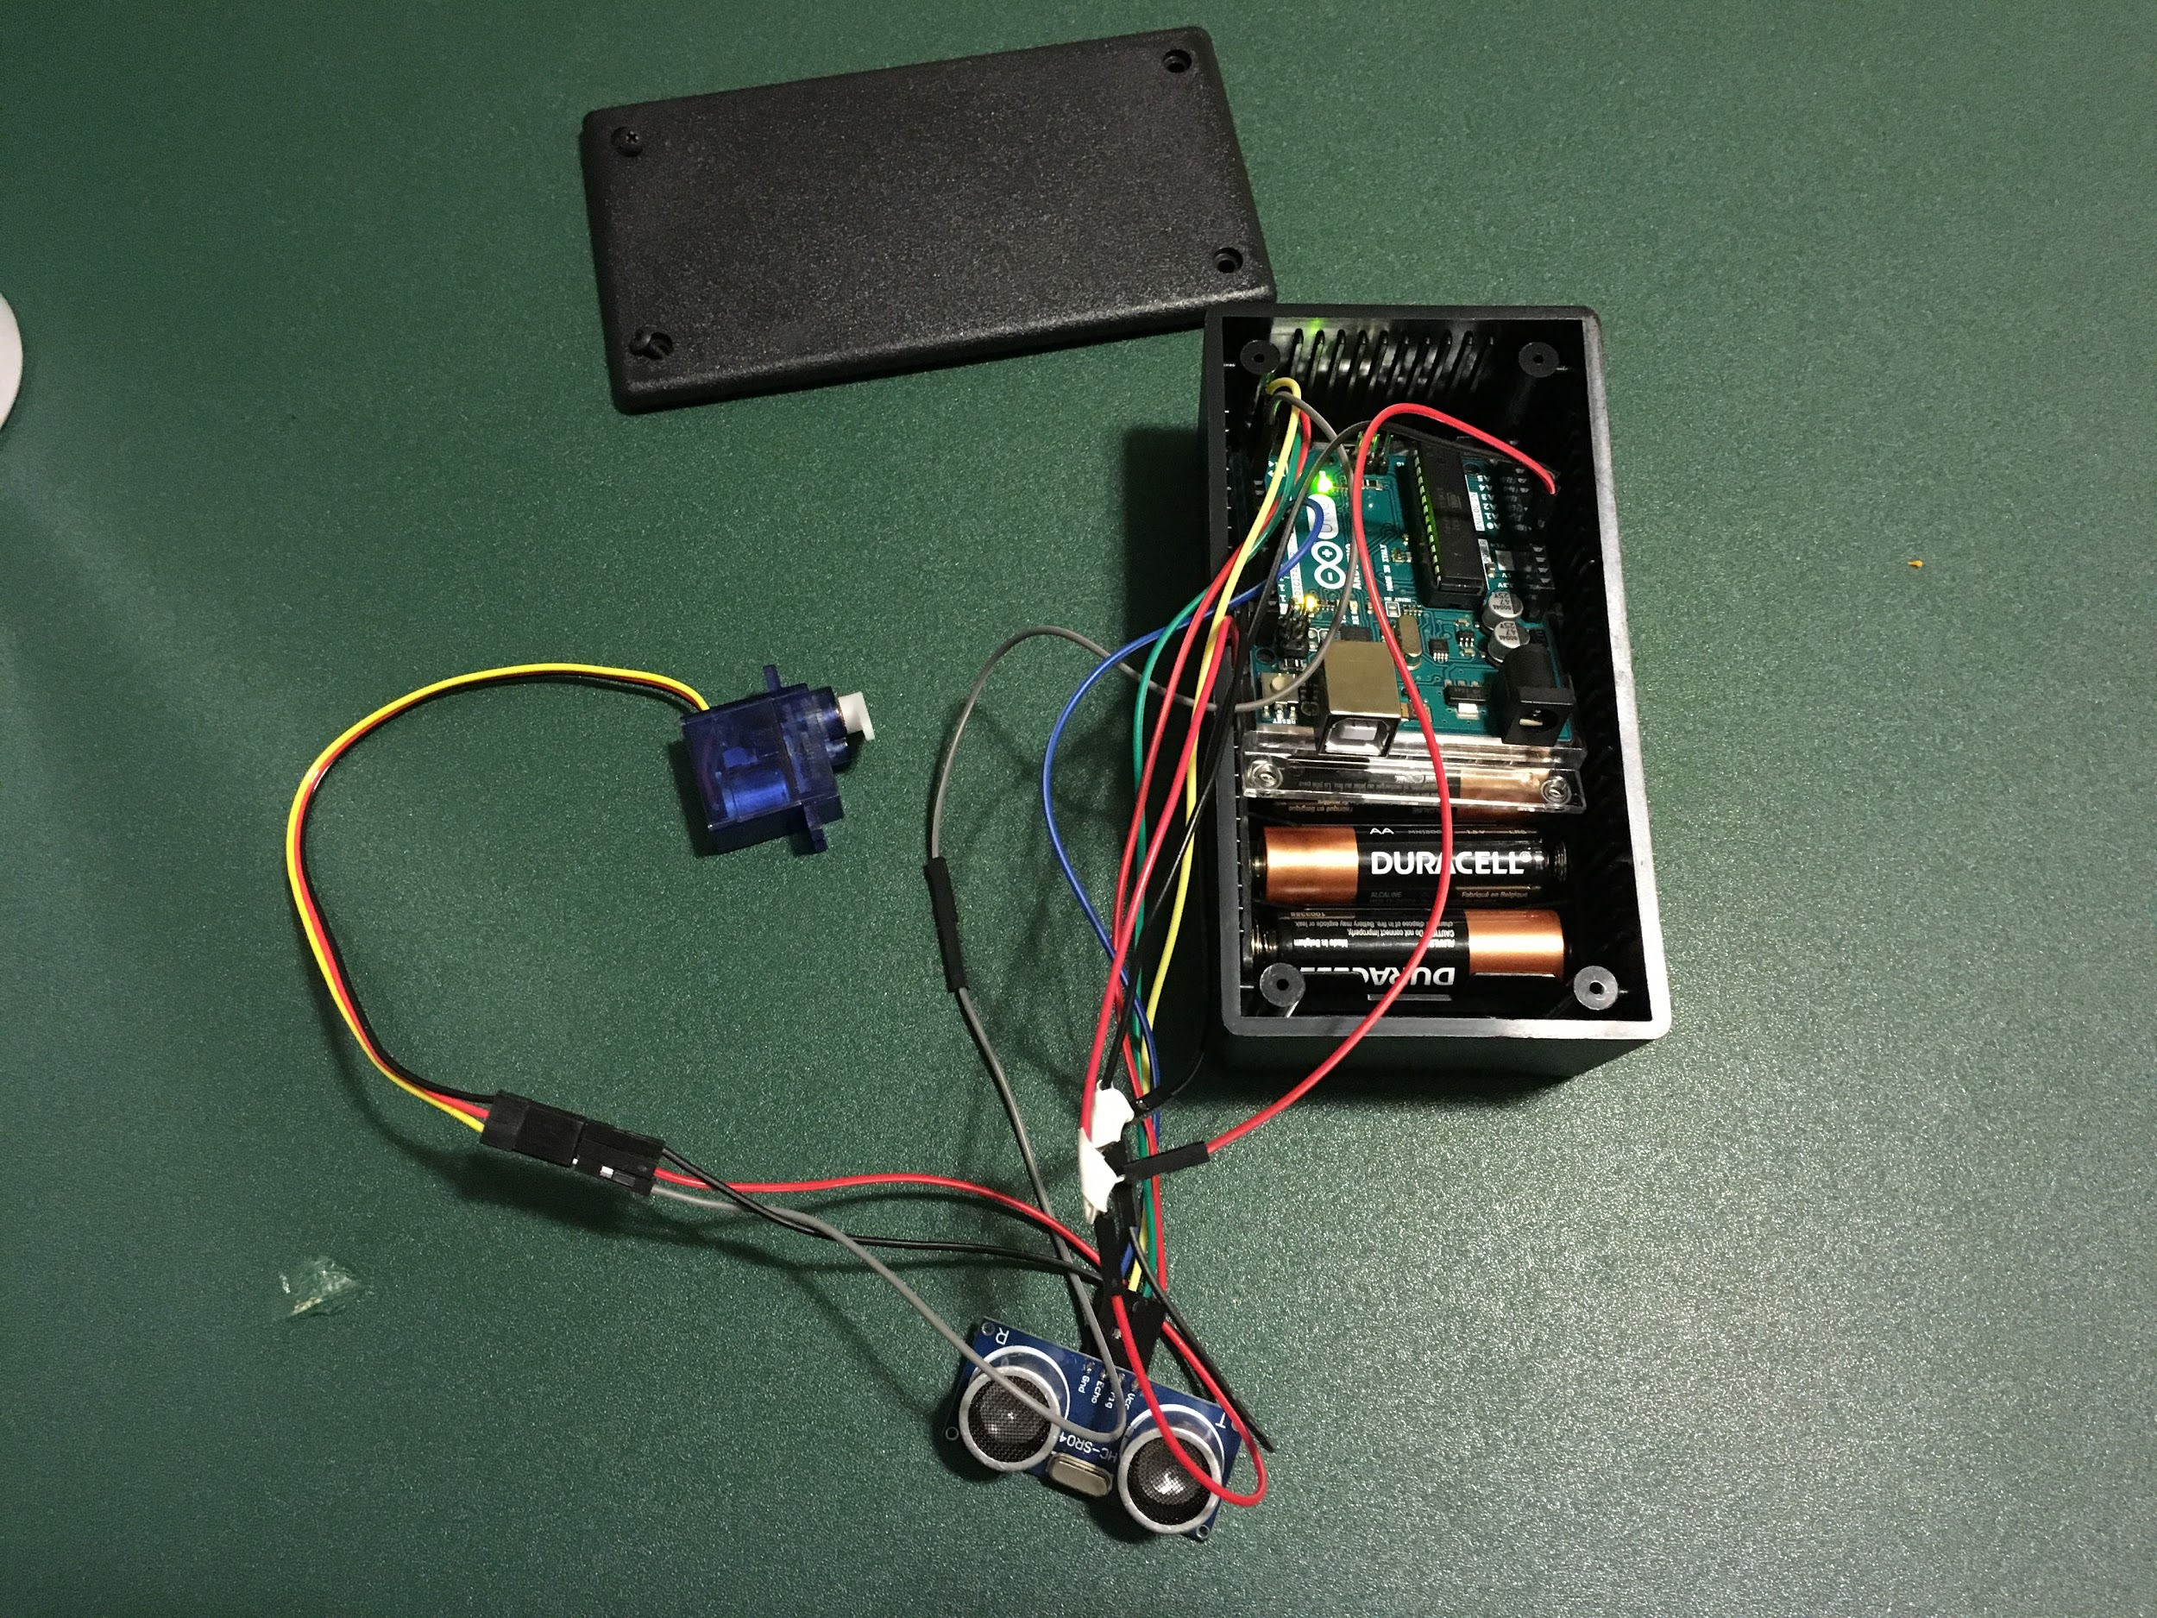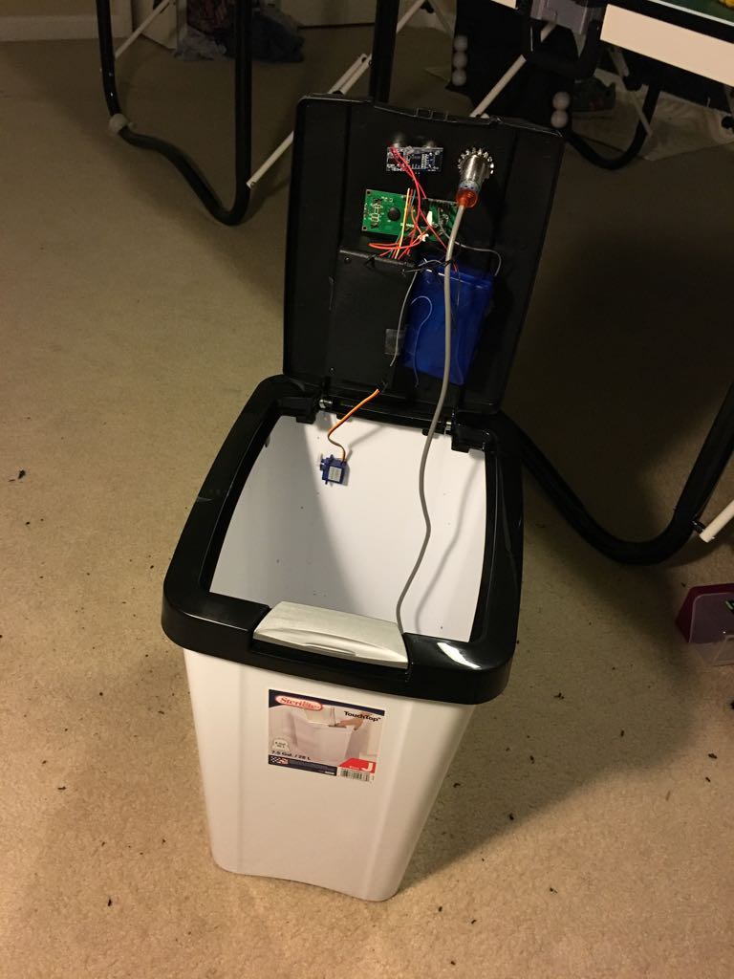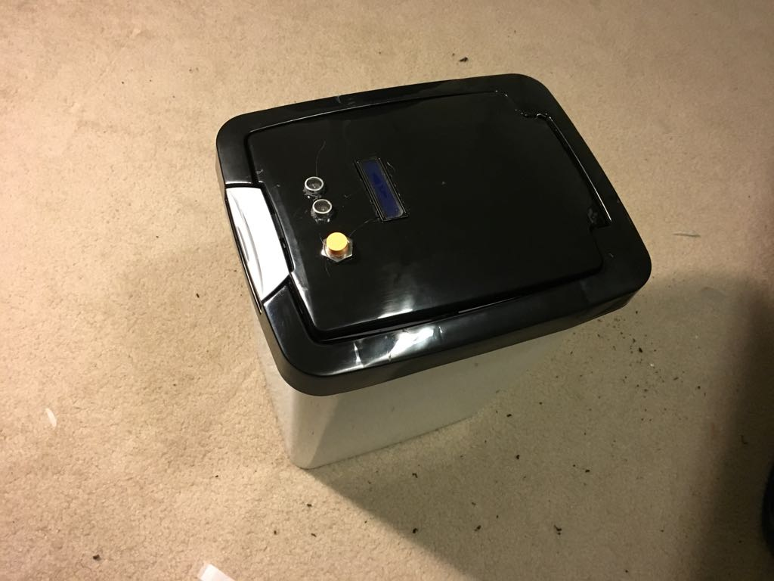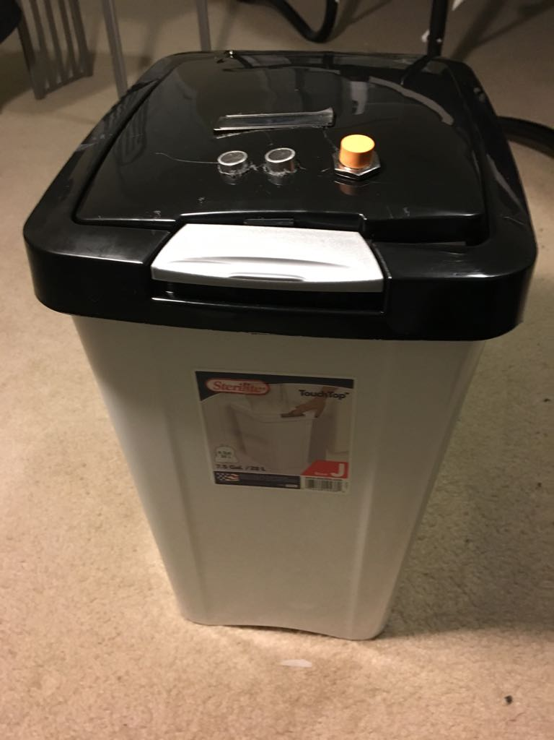

We built individual module components (Metal detector, motion detector, LCD panel). We assembled prototype device box with ultrasonic sensor, servo motor with the uno board then connected the other programs/sensors to the mega2560 and attached it to near the trash bin lid for better sensing proximity.

**Test & Evaluate:** Unit Testing and Integration of Modules:

Did the Unit Testing for each module separately and captured the test results for the relevant test

scenarios. Post successful unit testing and Integration of modules, performed end to end testing.

Below are few of the System/Integration test scenarios we used and test results we obtained.

**Data/Results:**

|  |  |  |
| --- | --- | --- |
| Module | Scenario | Results |
| Metal Detector (Module 1) | Place metal items in front of the trash bin to see if the lid would open. | Trash bin lid did not open |
| Place Non metal item in front of the trash bin to see if the lid would open. | Trash bin lid opened. |
| Motion Detector (Module 2) | Tested with 4.5 volts battery as the DC Servo works from 4.5 volts onwards to 6 volts. | The motor did not rotate well and we understood that the battery power is not sufficient and finally worked well when we increased the battery power from 4.5v to 6v |
| We created some motion signals by putting our hand near to the Motion Detector where we used UltraSonic Sensor for this module. | We see the motion signals flow through our code print statements in Arduino IDE - > Tools -> Serial Monitor |
| Display Panel (Module 3) | Sent a text message ‘Please Recycle’ from the program to observe the same text on LCD display | Found ‘Please Recycle’ text on LCD display panel |
| Sent a text message ‘Please Recycle’ from the program to observe the same text on LCD display for four seconds. | Found ‘Please Recycle’ text on LCD display panel for four seconds. |
| Place metal items in front of the trash bin | Found ‘Please Recycle’ text on LCD display panel |
| Integrated Device (With all above three Modules): | Place a metal soda tin in front of the device | Trash bin lid did not open and found ‘Please Recycle’ text on LCD display panel |
| We put a non metal soda tin in front of the device | Trash bin lid did open and found no text on LCD display panel |

**Bug Fixing:** Below is list of few of the bugs identified and resolved.

* The first program Metal Detector module code did not get uploaded to Arduino Mega due to Arduino Board/Process/Port were not configured and fixed it accordingly.
* Battery power 4.5v not sufficient and increased to 6v
* In Motion Detector module, DC Servo did not work due to compatibility of the model and then we fixed it with the DC Servo model LS-0009AF
* LCD Display Panel initially did not work and after debugging we found that the related circuit connections were wrong and fixed them.

**5. IMPROVE:**

**Recommendations/Next Steps:** Enabling below capabilities are been considered for future enhancements for multi iteration releases for full blown product.

* Plastic, cardboard, paper and glass sensor are must have capabilities.
* Notification to user’s phone with recyclable data is nice to have future.
* Extend product capabilities from residential to Commercial usage.
* Monthly reports to user telling them how much they have recycled

**6. SHARE SOLUTION:**

**Key Advantages:**Minimizes intermixing of recyclable items with trash in turn helps

* + Reduction of chemical toxic gases generation from Landfills
  + Increased Opportunity on recycling and saves energy

Below are the **key strengths** of current prototype model:

* Uniqueness of the product to deliver various capabilities like metal detection, LCD display and auto lid open/close.
* Improves the efficiency of recyclable items identification.
* The product has foundational framework with focused capabilities but has potential to be fully extendable to meet broader diversified needs.

**Weakness :** Proximity inductive sensor range is limited to 8 mm.

**Check if Solution meets Client Requirements:**

Currently we addressed 1) metal detection scope only 2) with individual loading of the items in trash bin 3) along LCD display for prompts and 4) lid auto open/close for residential needs.

**Appendix:**

1. Detailed Budget Sheet:

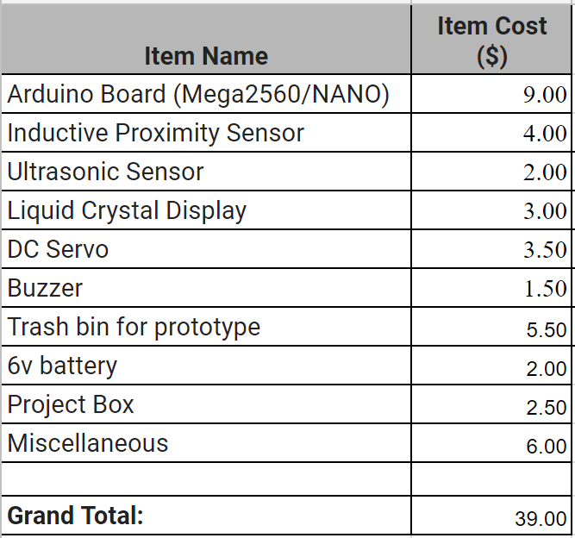

1. Arduino code reference: <https://github.com/theroboknights/r3/>

**Bibliography:**

* Programing Language References: <https://www.arduino.cc/reference/en/>
* Engineering Standards Reference: <https://nextgeneration.org>
* <https://doitgreen.org/topics/climate-change/connection-between-recycling-and-global-warming/>
* <https://wastersblog.com/604/waste-separation-methods/>
* <http://www.eurekamagazine.co.uk/design-engineering-features/technology/sensors-identify-plastics-for-recycling/29331/>
* [https://www.howardcountymd.gov/Departments/Public-Works/Bureau-Of](https://www.howardcountymd.gov/Departments/Public-Works/Bureau-Of-Environmental-Services)
* <http://forum.arduino.cc/index.php?topic=477278.0>
* <http://msa.maryland.gov/msa/mdmanual/14doe/html/msa17104.html>